# INVENTORY AND CHECKOUT PREPARED FOR

#### 1 DELAHAY HOUSE

#### 15 CHELSEA EMBANKMENT

#### LONDON

SW3 4LA

19TH AUGUST 2016/ 21ST APRIL 2021

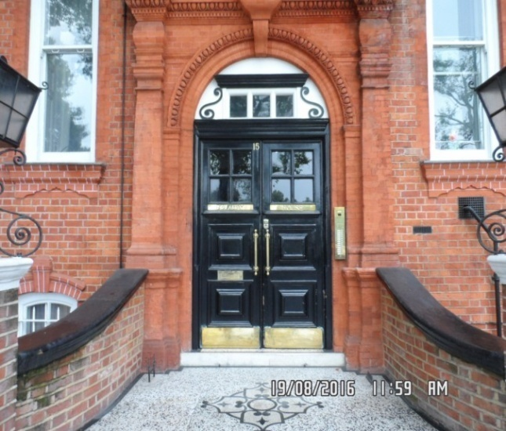

CLIENT: LONDON CENTRAL PORTFOLIO

# REF: MBPS-002/ MBPS-002

#### INSPECTED BY: GARY KRIENKIE

Property Size: 1 Bedroom / 1 Bathroom / 1 Reception –Furnished Flat



‘WINDY RIDGE’ 99 COWLEY HILL, BOREHAMWOOD, HERTS, WD6 5NA, TEL: 020 8 386 0950 –

MOBILE: 077 67 647 647 EMAIL: [info@inventorys.net](mailto:info@inventorys.net) www.inventorys.net

Registered No: 4263261

Safety Disclaimer

This inventory report is prepared as an ‘as seen snapshot’ of the property and its contents at the time of the designated inspection and is compiled as a fair and accurate record for the properties internal condition and contents. This does not form any part of a valuation or structural report.

This inventory is compiled on the basis that all items listed are in good order and clean. Any defects or soiling are noted where appropriate. Where inspections are carried out and the tenants’ belongings are in situ, it can be difficult for clerks to differentiate to that belonging to the landlord or tenant. Should the report contain inaccuracies the clerk (Independent Inventories (UK) Ltd ) will not be held responsible.

The clerk preparing the inventory is not an expert in electrical appliances, antiques, furniture style, fabrics, flooring, etc. All descriptions within this report are for identification purposes only in order that each item can be compared to its condition at the commencement of the tenancy.

Lofts and Cellars are not included unless they are converted and safely accessible. Contents will therefore not be noted or checked at checkin or checkout.

Plants and shrubs will not be itemised.

Belongings left by the landlord/agent in a locked room or outbuilding will not be inventoried and are the sole responsibility of the Landlord/agent. Items in garages/sheds such as garden equipment and tools will be inventoried, however tins of paint will not be itemised.

We do not undertake to move heavy items of furniture or access lofts, high-level cupboards, or any other inaccessible places. Contents which have been left in the above-mentioned areas, which have not been inventoried, are the sole responsibility on the landlord. We also do not undertake to open windows, but will confirm whether keys have been seen or not.

Any electrical appliances tested will be for power only and only where practicable. The clerks are not qualified electricians and will only confirm the visual condition of the electrical socket, wiring and or fitting as seen. Boilers, Heating Systems, Gas Fires, Water Supply and Radiators are not tested, and Independent Inventories (UK) Ltd will not take any responsibility for units left either on or off even if on automatic timers. Where smoke alarms and CO Detectors are tested this is for power only and should not be taken to mean that the alarms are in full working order. We only state their presence and cannot state the functioning of this equipment. No responsibility is taken for any damage or malfunction occurring during the testing of such alarms.

The relevant utility companies must check all meter readings, as we cannot be held responsible for any discrepancies. We are not held liable should meters not be located or inaccessible to read. For Health and Safety reasons we do not expect our clerks to access high level areas which involve using ladders/chairs.

The Fire & safety Regulations regarding furnishings, gas, electrical & similar services are ultimately the responsibility of the instructing principle. Where the inventory notes FFR label seen, this should not be interpreted to mean that the item complies with the furniture & furnishings (fire) (safety) (Amendments) 1993. It is a record that the item had a label as described or similar to that detailed in the Guide to the regulations as published by the Department of Trade & Industry, January 1997, (or subsequent edition), attached at the time the inventory was complied.

Blinds in the premises are visually checked. We are unable to verify that the blinds comply with child safety requirements of BS EN 131202009 + A1:2014 placed on the manufacturer, supplier and professional installation of internal window blinds

It is the responsibility of the landlord/managing agent/tenant to agree between themselves the accuracy of the report, and Independent Inventories (UK) Ltd should be notified within 7 days of receipt of the report of any discrepancies within the report.

GENERAL GUIDANCE NOTES

Independent Inventories do not have site of tenancy agreements or other agreements made between the tenant, landlord and management company. As these are guidance notes only it is always advisable that the tenancy agreement is cross referenced. This report will indicate whether in our opinion the tenant is liable for the deterioration or whether it is considered fair wear & tear. Independent Inventories may suggest maintenance, cleaning or tenant’s liability at checkout, but the final responsibility of these suggestions will fall with the landlord or managing agent in respect of the original tenancy agreement. We do not suggest costs of any items, these should be sourced from the relevant contractors by the landlord or managing agent.

CLEANING

We recommend that a professional cleaning company is employed at the end of the tenancy, unless alternative arrangements have been agreed with the Landlord/Managing Agent. Receipts from professional cleaning and carpet cleaning companies must be present to the clerk at the checkout inspection.

If the standard of cleaning is not satisfactory most Landlords/Managing Agents will contract a cleaner and their charges will be charged to the tenant unless otherwise stated in the tenancy agreement.

DECORATION

It is accepted that during the course of the day to day living scuffs will appear on walls and woodwork. However should the marks be found to be excessive charges will be made to you the tenant, unless otherwise stated in the tenancy agreement.

LIGHTING

If the lights are working at checkin then it is normal, if lights are not working at checkout, for these to be the responsibility of the tenant to replace bulbs or to be charged accordingly, unless otherwise stated in the tenancy agreement.

GARDENS/PATIO

If the standard of the garden/patio is found to be untidy compared to the start of the tenancy the Landlord/Managing Agent are entitled to employ a contract gardener and the charge will be made to you the tenant, unless otherwise stated in the tenancy agreement.

MAINTENANCE ISSUES

We recommended should any maintenance issues arise you contact the Landlord/Managing Agent immediately so they can deal with the matter. Should we recommend items require maintenance once a property has been checked out, this is purely stating that an item will require fixing/attention, we are not advising as to whose responsibility this and your tenancy agreement will need to be checked.

CHANGES TO PROPERTY

We recommend that if you wish to make any changes to the décor or remove any of the Landlords belongings you contact the Landlord/Managing Agent for permission and have this confirmed in writing to ensure there are no discrepancies at the end of the tenancy.

TENANTS INFORMATION FOR CHECKING OUT OF PROPERTY

It is important at the checkout that:

1. All cleaning should be completed prior to the checkout appointment as per the tenancy agreement.
2. All personal items must be removed prior to the check out.
3. All items should be in the same location as per the inventory, any stored items should be unpacked and also returned to the same location.
4. If the Inventory clerk has to search for items or you still have belongings in the property to be removed this will result in additional charges being made to the tenant.
5. All beds should be left unmade with the linen folded. Bedding & towels should be cleaned & ironed where relevant.
6. All food items should be removed, freezers defrosted & doors left open & electricity turned off.
7. All light bulbs etc. should all be in working order as at check in.

The property should be left in a clean and tidy condition especially carpets, curtains, windows, upholstery appliances etc. We would suggest that you refer to your tenancy agreement in this matter.

If you are not ready to leave it may not be possible to carry out the checkout. In this case a return visit will be necessary resulting in a cancellation charge.

All keys to the property must be handed over at the time of checking out to the Inventory clerk or alternatively to the agents prior to the check out taking place.

The Inventory Clerk acts as an independent and reasonable body and will avoid unnecessary criticism or derogatory comments when compiling or checking the Inventory.

At the termination of the tenancy the inventory will be checked and any obvious or significant discrepancies will be reported to the Managing Agent/Instructing Principal. This report will indicate whether in our opinion the tenant is liable for the deterioration or whether it is considered fair wear & tear. Normal fair wear and tear will be assessed on the lengthy of the tenancy and type occupancy.

INDEX

PAGE

|  |  |
| --- | --- |
| UTILITY READING | 1 |
|  |  |
| KEYS | 3 |
|  |  |
| GENERAL SUMMARY AT CHECKIN | 4 |
|  |  |
| INSTRUCTION MANUALS | 5 |
|  |  |
| ENTRANCE HALLWAY | 6-13 |
|  |  |
| RECEPTION | 14-25 |
|  |  |
| KITCHEN | 26-36 |
|  |  |
| BATHROOM | 37-44 |
|  |  |
| BEDROOM | 45-54 |
|  |  |
| DECLARATION AT CHECK IN | 55 |
|  |  |
| ADDITIONAL AMENDMENTS | 56 |
|  |  |
| SIGNED SCHEDULE OF CONDITION | 57-59 |

**UTILITY READINGS / KEY LIST& INSTRUCTION MANUALS**

|  |  |  |
| --- | --- | --- |
| **ELECTRIC** | **GAS** | **WATER** |
| METER NUMBER:  D00A56203 | METER NUMBER:  Not located | METER NUMBER:  Not located |
| READING:  52745 | READING:  Not located | READING:  Not located |
| LOCATION:  Hallway cupboard | LOCATION:  Not located | LOCATION:  Not located |

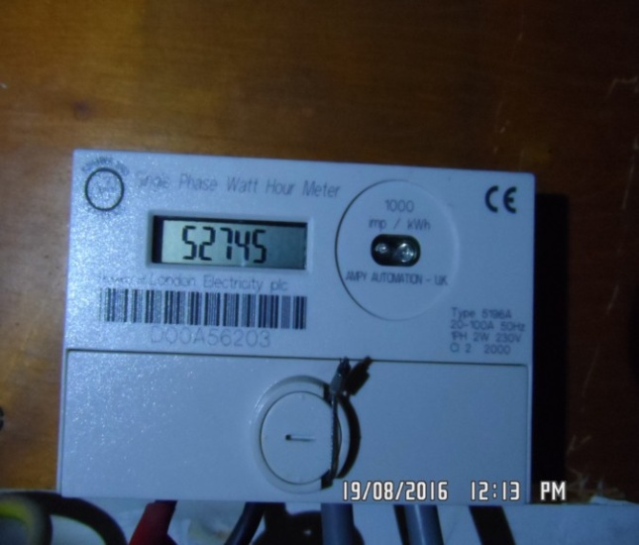

|  |  |  |
| --- | --- | --- |
| **ELECTRIC** | **GAS** | **WATER** |
| METER NUMBER:  D00A56203 | METER NUMBER:  Not located | METER NUMBER:  Not located |
| READING:  70526 | READING:  Not located | READING:  Not located |
| LOCATION:  Porter cupboard, access via porter\*\*\* | LOCATION:  Not located | LOCATION:  Not located |

|  |
| --- |
| **LOCATION OF:** |

|  |  |  |
| --- | --- | --- |
| **STOP COCK** | Not located | |
| **FUSE BOARD** | Hallway cupboard | |
| **ALARM PANEL**  **This has not been tested** | None | MAKE: |

|  |
| --- |
| **FIRE SAFTY** |

|  |  |
| --- | --- |
| **SMOKE ALARM** | Power light on |
| **CARBON MONOXIDE ALARM** | N/A |

|  |  |  |
| --- | --- | --- |
| **KEYS AT CHECKIN** | **KEYS AT CHECKOUT** | |
| **KEY TYPE / SERIAL NUMBER / QTY** | **KEY TYPE / SERIAL NUMBER / QTY** |
| 1 x Bramah silver (14 245371) |  |
| 1 x Bramah silver (85D3803) |  |
|  |  |
|  |  |
|  |  |
|  |  |
|  |  |
| **KEYS RECEIVED BY: Agent (management keys used)**  \\Maalkum-pc\mbps\20-Aug-16\II\20TH AUGUST\1 DELAHAY HOUSE\Pictures\New Folder\SAM_6040 (Copy).JPG | **KEYS RETURNED TO: Picked up and dropped off at LCP, picture of keys taken\*\*\*** | |

|  |
| --- |
| **GENERAL SUMMARY** |

|  |  |  |
| --- | --- | --- |
| **ITEM** | **CHECKIN NOTES** | **CHECKOUT NOTES** |

|  |  |  |  |
| --- | --- | --- | --- |
| **GENERAL CONDITION** | | Professionally cleaned for the start of tenancy | Professionally cleaned for end of tenancy |
| **ODOUR** | | N/A | N/A |
| **DECORATIVE ORDER / WOODWORK** | | Advised freshly painted  Good order  Defects as noted  Woodwork scuffed/ chipped | Defects as noted  Woodwork scuffed/ chipped |
| **FLOORING** | | Good order  Defects as noted  Vacuumed for start of tenancy | Vacuumed for end of tenancy |
| **CURTAINS / BLINDS** | | Vacuumed in situ for start of tenancy |  |
| **BLIND REGULATIONS** | |  |  |
| **UPHOLSTERY** | | Vacuumed in situ for start of tenancy  Good order  Defects as noted | Defects as noted |
| **FFR LABELS** | FFR labels seen | |  |
| **LINEN** | In use | | In use  Requires further cleaning |
| **LIGHTS** | All working order | | Bulbs missing / not working |
| **KITCHEN / APPLIANCES** | All clean order  All appliances power tested  Fridge left shut power on  Freezer left shut power on | | All clean order  All appliances power tested  Fridge/Freezer left shut power on |
| **BATHROOMS/**  **WC** | Clean  Mildew to areas as noted  Water outlets tested and working | | Clean  Water outlets tested and working |
| **WINDOWS** | Requires further cleaning  Fitments complete | | Requires further cleaning  Fitments complete  Clean to interior |
| **GARDEN** | N/A | | N/A |

|  |  |
| --- | --- |
| **MANUALS SUPPLIED AT**  **CHECKIN** | **MANUALS RETURNED AT**  **CHECKOUT** |
| **APPLIANCE / MAKE** | **APPLIANCE/MAKE** |
|  | NOT SEEN |
|  |  |
|  |  |
|  |  |
|  |  |

 \*N.B – Heavy items will not be moved or inspected behind/under, for health & safety reasons. We will not be held liable should any damages/stains/marks be found during the tenancy in these areas. Should the occupant find any of the above they should, inform the landlord/agent immediately and if/where possible take photographic evidence and pass to the relevant parties.

# ENTRANCE HALLWAY

|  |  |  |  |
| --- | --- | --- | --- |
| **Entrance Door** | Grey painted frame, white painted panelled door  Brass Evva lock  Brass letterbox  Brass door knob  Painted over chubb lock to low level and high level  White plastic door bell fitted to right hand side  Chrome threshold | 1. Painted over cable to top left and right hand side of the frame  2. 1 x Lock removal hole with 1 fitment hole to the left hand side  3. Very discoloured to edges and chipped  4. Scuffed and chipped to base and panels  5. Doorbell not working  6. Threshold is worn  7. Brass is tarnished, especially the door knob  8. Upper panel is chipping  9. Discolouration around frame |  |
| **Interior** | White painted frame, white painted panelled door  Painted white barrel lock  Brass banham lock  2 x Painted over Chubb lock covers  Return of brass letterbox – no flap | 1. Painted over cable clipped to left, right and top sides  2. Painted over defects to door and frame  1 or 2 x very light usage marks  Shading to paintwork |  |

# ENTRANCE HALLWAY

|  |  |  |  |
| --- | --- | --- | --- |
| **Ceiling** | Painted white with white painted coving  1 x Smoke alarm | 1. Smoke alarm not tested – cover is loose |  |
| **Walls** | Painted stone | 1. Painted over defects  Scattered minor mid to low level scuffs  Light general usage |  |
|  | Back wall  2 x Chrome wall mounted lights  1 x High level black metal curtain pole  1 x White plastic single light switch  1 x Cream entry phone | 1. Painted over defects  2. Working  3. Perspex cover appears warped  4. Pole is paint marked  5. Entry phone not tested |  |

# ENTRANCE HALLWAY

|  |  |  |  |
| --- | --- | --- | --- |
| **Walls cont..** | Left hand side wall  Entrance to Reception |  |  |
|  | Front wall  1 x White plastic single light switch  Entrance to bathroom  1 x White plastic isolator switch  1 x White plastic double light switch  2 x White plastic fuse points  1 x White plastic double socket  Thermostat low level | Plaster missing under 1 x fuse point  Plaster cracking around it |  |
|  | Right hand side wall  Entrance to bedroom 1 |  |  |
| **Lighting** | 1 x Chrome and Perspex wall mounted light | All bulbs working |  |
| **Woodwork** | Painted white | 1. 1 or 2 very minor marks  2. Cable clipped to right hand side  Painted over defects |  |

# ENTRANCE HALLWAY

|  |  |  |  |
| --- | --- | --- | --- |
| **Flooring** | Beige fitted carpet | 1. Worn to tread  2. Few minor black spot marks forward of entry and bathroom |  |
| **Built in cupboard 1 – back wall** | White painted frame, white painted louvre panelled door  White and gilt ceramic handle  Interior: Painted white  Ceiling and walls painted white  Wood laminate flooring  4 x White painted shelves  1 x Wood baton housing electricity meter  1 x Hager fuse box | 1. Painted over defects to frame and door  2. Cable clipped to top and left hand side frame  3. Painted over defects to interior door with scuffs at mid/ high level  4. Generally scuffed and well in use to ceiling and walls  5. Edges to shelves are chipped and well in use  6. Baton is paint marked  7. Couple of chips to top edge  9. Further usage  10. Walls and shelves have heavy scattered scuffs, rubs and soiling throughout with orange sticky tape residue |  |

# ENTRANCE HALLWAY

|  |  |  |  |
| --- | --- | --- | --- |
| **Built in cupboard – contents** | Blue Miele vacuum with attachments | Not tested |  |
| **Built in cupboard 2** | White painted frame, high level white painted louvre panelled doors  2 x Chrome pulls  Interior: Painted cream  Ceiling and walls painted white | 1. good order  2. Walls are heavily scuffed  3. Ceiling is cracking to edge |  |
| **Built in cupboard 3** | 2 x White painted frame, low level white painted louvre panelled doors  2 x Chrome pulls  Interior: Painted white flush door  Ceiling and walls painted cream  1 x White plastic fuse point  Floor painted cream | 1. Good order  2. Painted over defects  3. Interior doors are in good order with minor scattered scuffs  4. General light scuffs and usage marks  5. Filled holes to the left hand side  6. Interior shelf and base shelf both heavily scuffed |  |

# ENTRANCE HALLWAY

|  |  |  |  |
| --- | --- | --- | --- |
| **Built in cupboard 3 – contents** | 1 x Chrome hanging rail  Water tank and associated pipe work |  |  |

Exterior door Exterior door

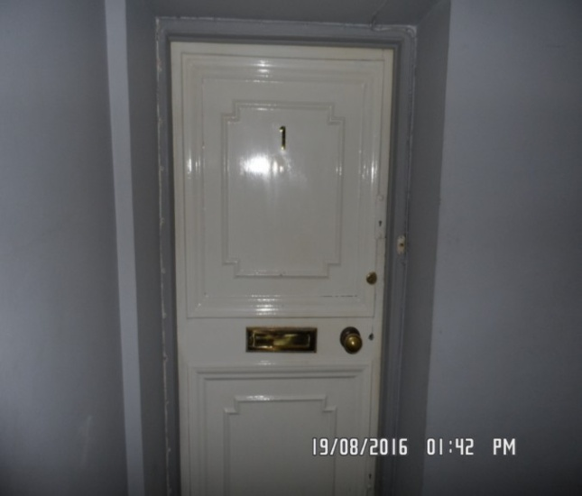 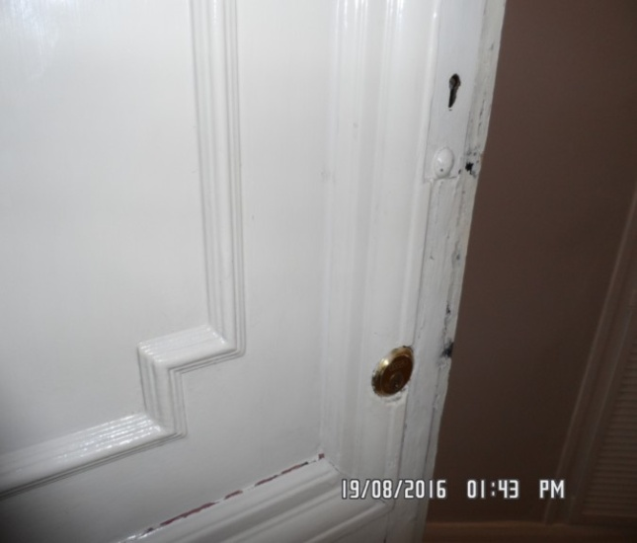

Hallway Hallway

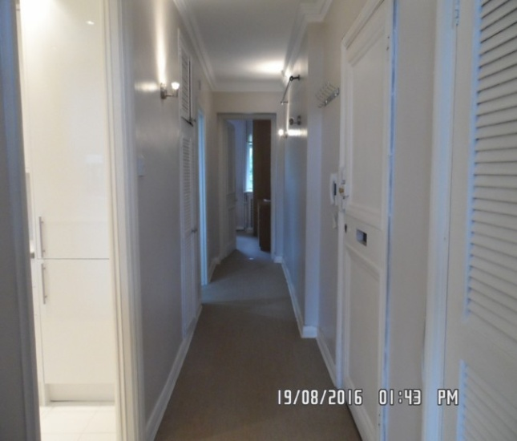 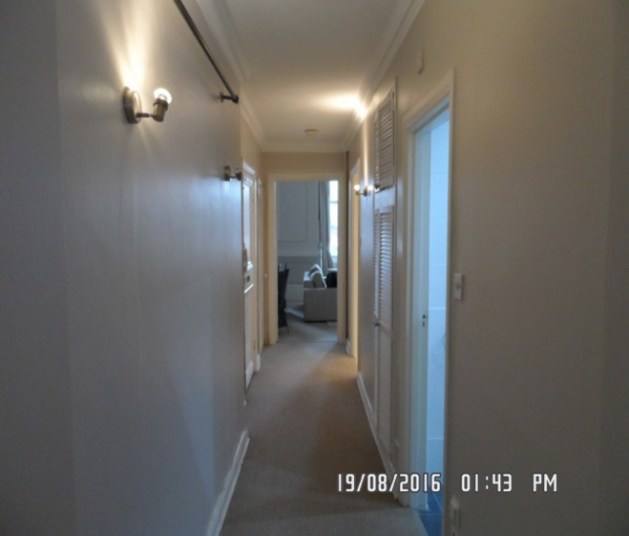

Carpet Skirting

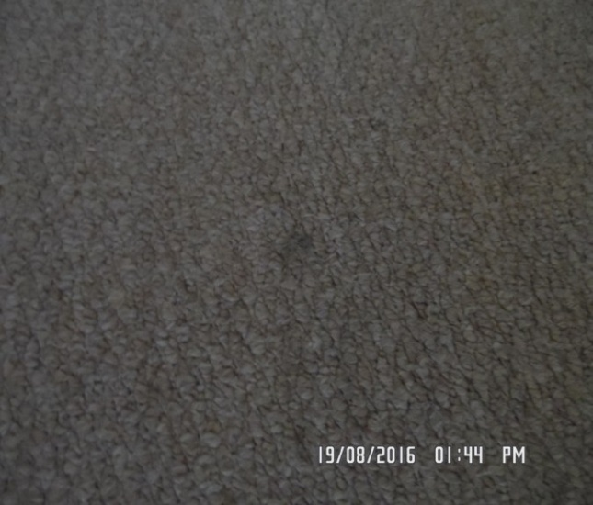 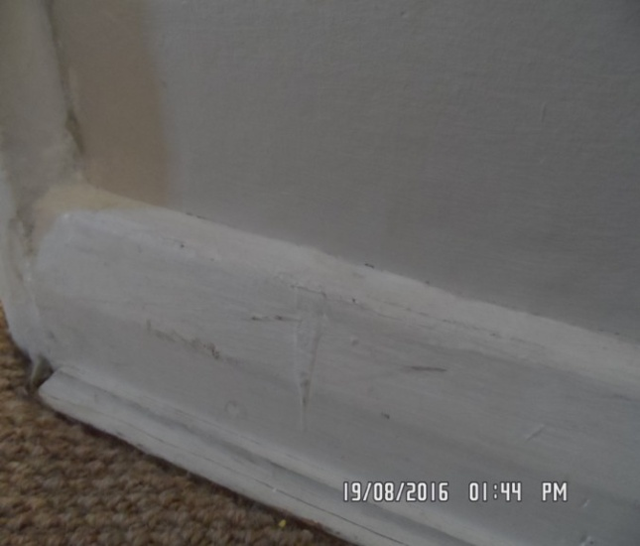

Curtain rail Smoke alarm

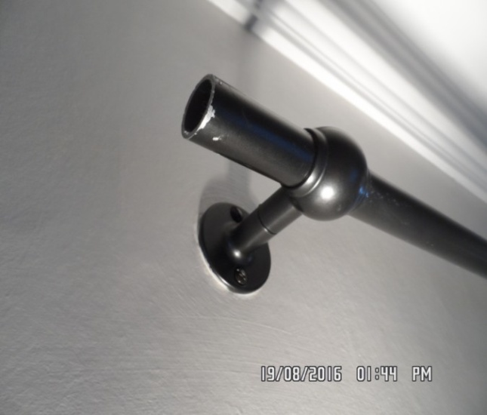 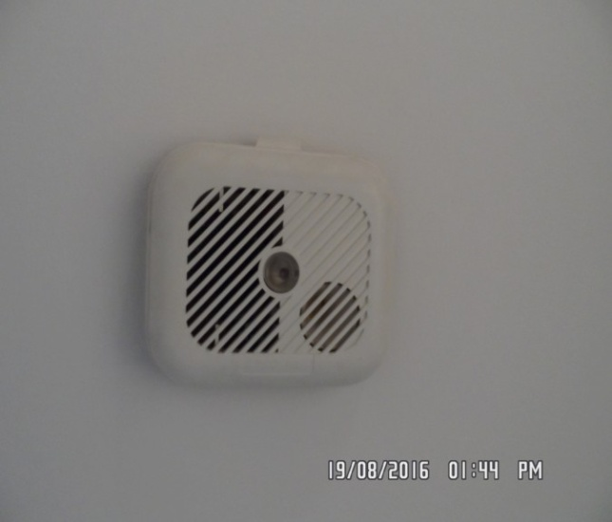

Cupboard 1 door Cupboard interior

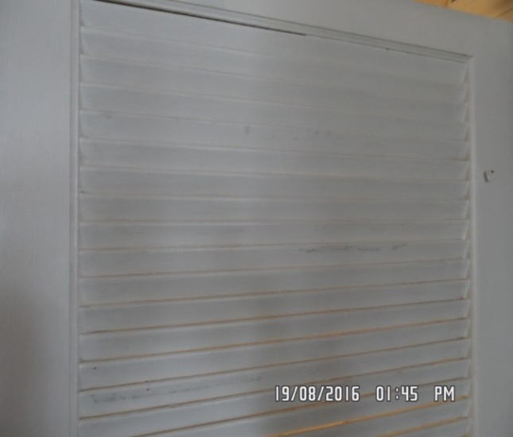 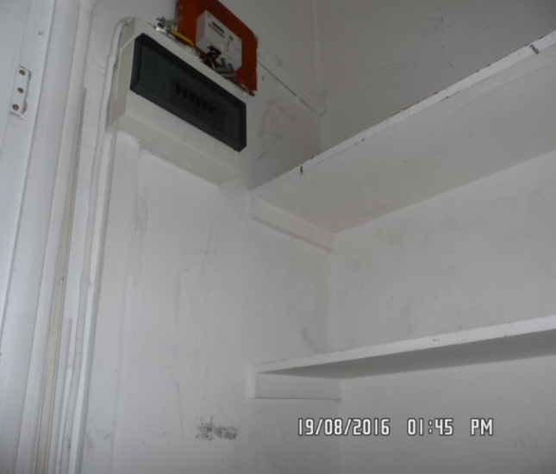

Cupboard interior Cupboard 2 high level

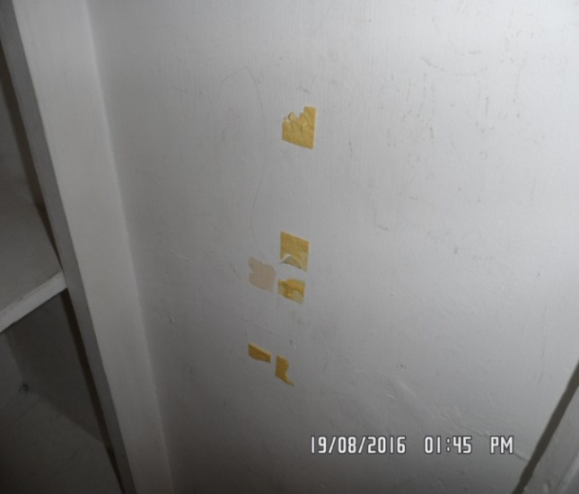 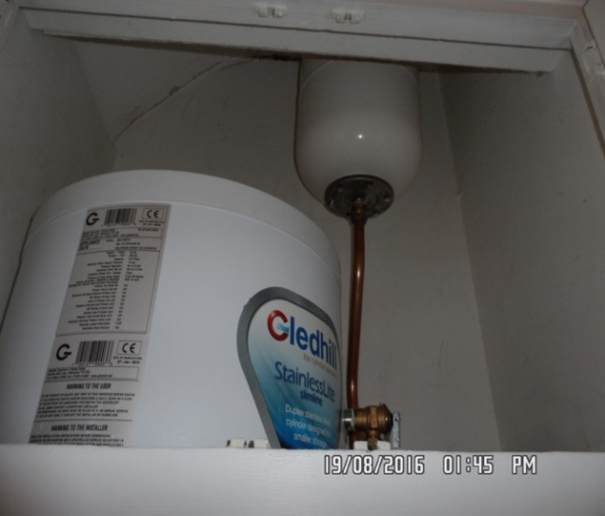

Cupboard 2 low level

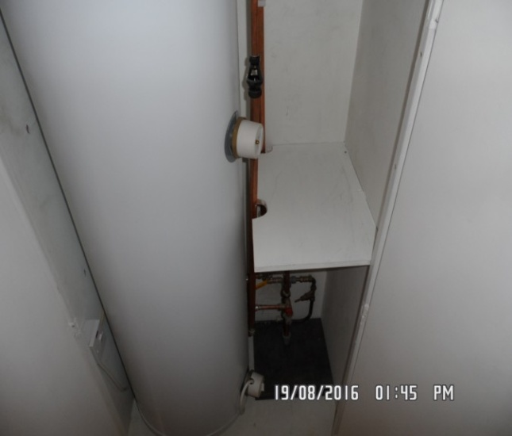

# RECEPTION

|  |  |  |  |  |
| --- | --- | --- | --- | --- |
| **Door** | White painted door frame, white painted panelled door  White ceramic and gilt finger plate  White ceramic and gilt door knob  White ceramic and gilt key cover  Brushed steel threshold | 1. Cable clipped to left hand side  2. Good order with painted over defects  3. Door knob is cracked to top  4. All ceramic and gilt are slightly worn and marked  Paint marked  5. Threshold is slightly marked  Some slight cracking to exterior panelling  1 or 2 x scattered minor scuffs and chips  Cracking to panelling interior at high level |  |  |
| **Interior** | White painted door frame, white painted panelled door  White ceramic and gilt pull  White ceramic and gilt lock cover | 1. Painted over defects  2. Cable protruding from low level right hand side |  |  |
| **Ceiling** | White painted panelled | 1. Good order |  |  |

# RECEPTION

|  |  |  |  |  |
| --- | --- | --- | --- | --- |
| **Walls** | Painted stone panelled with darker stone below dado  White painted dado rail | 1. Painted over defects  2. Scattered minor mid to low level scuffs above and below railing and on  3. General usage |  |  |
|  | Back wall  1 x Brass double dimmer switch  1 x Hatch entry to kitchen with white painted frame  1 x White plastic double socket | 1. 1 x Nail  2. Hatch frame is painted over defects – no door  Paint is peeling and bubbling above hatch  Numerous chips by socket  Red line mark mid to low level approximately 2” |  |  |
|  | Left hand side wall  1 x White plastic double socket  1 x Metal curtain cleat  1 x Wall mounted chrome and Perspex light | 1. Light working order  2. Flaking to paint left hand mid level of window |  |  |

# RECEPTION

|  |  |  |  |  |
| --- | --- | --- | --- | --- |
| **Walls cont..** | Front wall  2 x Metal wall mounted cleats | 1. Painted over defects  2. Cables protruding from right hand side of window -NTL box  3. 1 x further wall plug in situ  1 x has fallen off - wall plug in situ  Cracking to panel below window on right hand side  Shading below right hand window and flaking in places |  |  |
|  | Right hand side wall  2 x Chrome lights mounted to mirror  1 x Plastic double socket  1 x Plastic fuse switch | 1. Painted over defects at high level above mirror  2. Good order otherwise  3. Small chip to low level beading |  |  |

# RECEPTION

|  |  |  |  |  |
| --- | --- | --- | --- | --- |
| **Woodwork** | Painted white  2 x White plastic telephone sockets  1 x Area of skirting is window seat  2 x Cushions with black/ cream piping | 1. Painted over defects  3. Cable clipped around room especially to left hand side  Skirting cracking left hand side fireplace  1. Cushion is in use, 1 or 2 spot marks seen  Few scattered minor scuffs  1 x nail to top seen  In use |  |  |
| **Flooring** | Beige fitted carpet | 1. Worn to tread  2. Cluster of spot marks on entry  3. Furniture pressure marks |  |  |

# RECEPTION

|  |  |  |  |  |
| --- | --- | --- | --- | --- |
| **Window 1 – left hand side** | White painted frame, white painted sash windows  White plastic secondary double glazing fitted | 1. Painted over inset handles to lower frame  3. Glazing is slightly smeary and there are cleaning scratches to the glazing  Requires further cleaning to exterior glazing  Slightly dusty to frames and sills |  |  |
| **Window 2 – right hand side** | White painted frame, white painted sash windows  White painted sill  1 x Chrome centre lock  3. 1 x Painted over inset handle to low level  UPVC secondary double glazing fitted with 4 white pulls | 1. Sash cord seen  2. Pulls are slightly discoloured  Dusty  Frame to secondary glazing shaded heavily on all |  |  |

# RECEPTION

|  |  |  |  |  |
| --- | --- | --- | --- | --- |
| **Window 3 – right hand side** | White painted frame, white painted sash windows  1 x Painted over white centre lock  1 x Painted over inset handle to low level  White painted sill  UPVC secondary double glazing fitted with 4 white pulls | 1. Sash cords intact  2. Frame is very discoloured  3. Glazing needs cleaningto exterior  4. Sill is slightly dusty |  |  |
| **Window 4 – right hand side** | White painted frame, white painted sash window  1 x Chrome centre lock  2 x Painted over inset handle to low level  Pair of UPVC secondary double glazed doors with 4 white pulls  White painted sill | 1. Too high to inspect properly – but 1 piece of lock appears to be missing  2. Appears damaged to low level left hand side of door and is discoloured |  |
| **Window 5 – right hand side** | White painted frame, white painted UPVC framed window  1 x Chrome centre lock  1 x Painted over inset handle to low level  1 x White painted over junction box fitted to sill  White painted sill  UPVC secondary double glazing fitted with 4 white pulls | 1. 3 x Cables protruding from right hand side  2. Frames are discoloured  3. Sill is slightly dusty  Cabling to low level frame left hand side |  |

# RECEPTION

|  |  |  |  |
| --- | --- | --- | --- |
| **Curtains – left hand side** | Beige just above floor length curtains with matching pelmet | Linings now in good order  Slightly creased / good used order |  |
| **Curtains – right hand side** | Beige just above floor length curtains with matching pelmet |  |  |
| **Tie backs** | 3 x Tie backs seen for 4 curtains |  |  |
| **Fireplace** | Cream marble mantle  Cream stone surround  White and grey marble hearth  Interior painted black  Black wrought iron fire with 2 doors with brass pulls | 1. Very aged and discoloured to mantle with numerous nicks and marks to the top including pink and orange staining  2. Numerous chips to angles of the surround and chipped to the top  3. Well in use and aged  4. Hearth is heavily scratched with numerous edge chips and staining and shading, scratches and generally well in use  5. Interior is discoloured to low level  6. 1 x Hole to right hand side  7. 1 x Hole to left hand side with cable protruding  8. Fire is generally in use, scratches to the top |  |

# RECEPTION

|  |  |  |  |
| --- | --- | --- | --- |
| **Dining table** | Glass with metal framework | Numerous scratches, chips and tape to base  Cracking paint  Some rust seen  Table is scratched |  |
| **Dining chairs** | 6 x Wrought iron chairs with greycoloured linen tie on covers | 1. Undercover is not inspected  2. All covers in use with minor very faint spot stains |  |
| **Sofa** | Beige 2-seater sofa with 2 base cushions and 2 back cushions | 1. Very faint Staining to seats and on arm  2. FFR labels seen |  |
| **Shelf unit** | Wrought iron shelf unit with 3 shelves | 1. Generally in good order  2. Some light usage marks and paint spots |  |
| **Chair** | Wicker chair set on wrought iron legs painted yellow | 1. Legs are slightly marked  2. Generally in good order |  |

# RECEPTION

|  |  |  |  |
| --- | --- | --- | --- |
| **Side tables** | 2 x Matching wicker circular side tablespainted white | 1. Light usage marks  1 x small section of wicker broken |  |
| **Window seat** | White painted frame, white painted lattice front covering to low level  1 x NTL box to right hand side – noted on window | 1. Seat is painted white with some old fitment holes  2. Top is in use and stained  3. Interior not closely inspected |  |
| **Cushions** | 2 x Black with cream piping bolster cushions | 1. Good order  General usage – noted previously |  |
| **Mirror** | 2 x Large wall mounted white framed mirror panels each with 4 chrome screw covers | 1. Slightly paint marked to edges  2. Good order otherwise |  |
| **Built in shelving unit** | 8 x White painted shelves | 1. In good order to right hand side of mirror  Showing some scuffing  Scattered usage marks to walls and shelves  Paint cracking on corner edges |  |

# RECEPTION

|  |  |  |  |
| --- | --- | --- | --- |
| **Coffee table** | 1 x light wood low coffee table | Good order |  |
| **Prints** | 2 x prints black framed plastic ?  1 x with red lips and smoke  1 x with “+” signs | 1 x cover scratched |  |
| **Vase** | 1 x black cream vase | Good order |  |
| **Rug** | Rug seen |  |  |
| **Miscellaneous** | Minor assorted items including vases etc |  |  |
| **Shelf** | 1 x Metal shelf rack |  |  |

Reception Reception

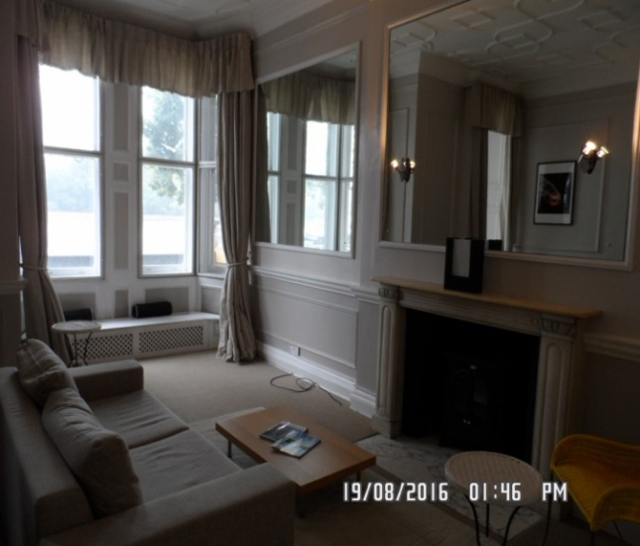 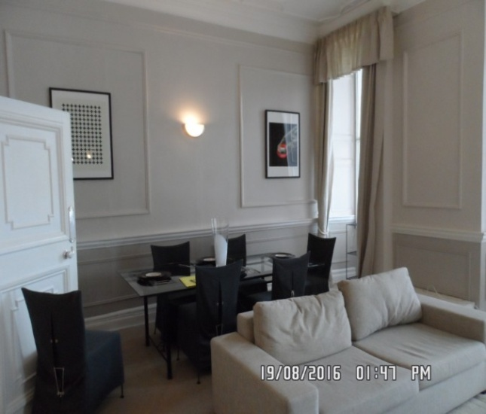

Reception Reception

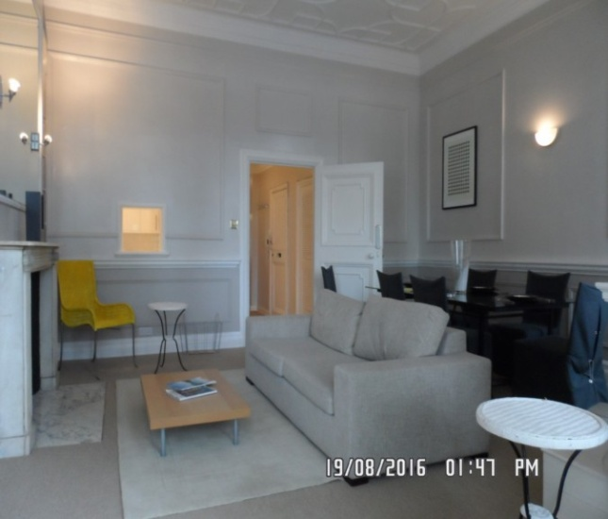 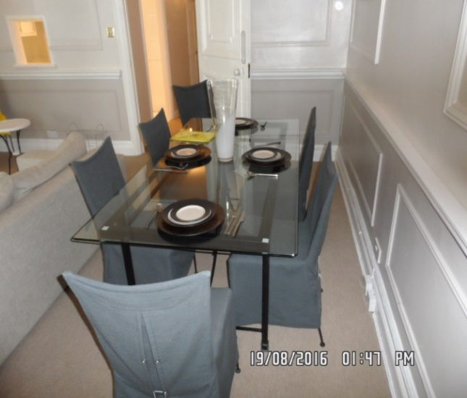

Left window wall Wall

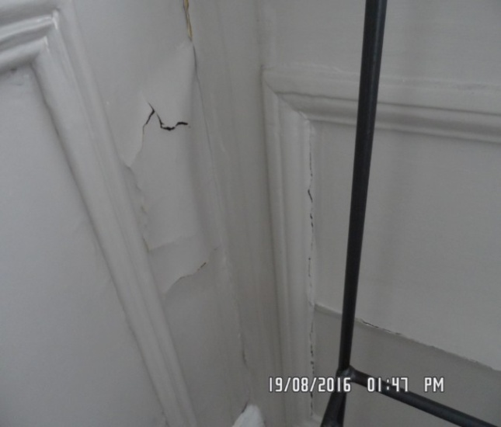 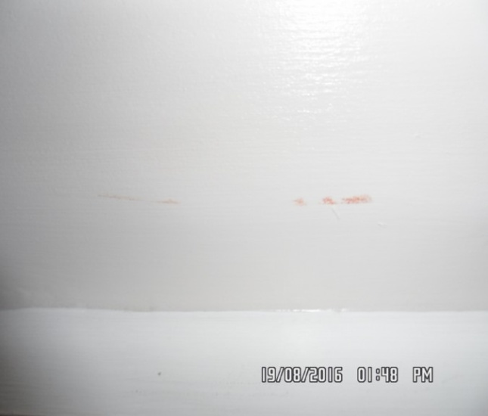

Fireplace Wall

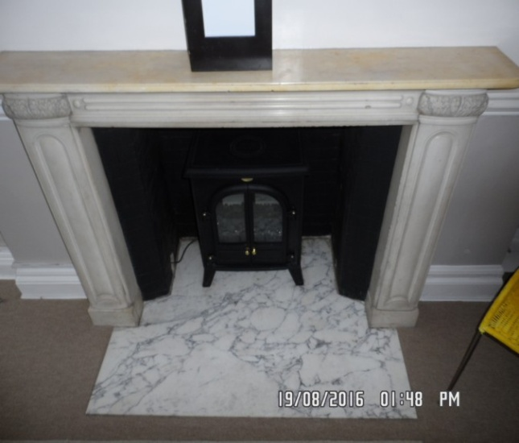 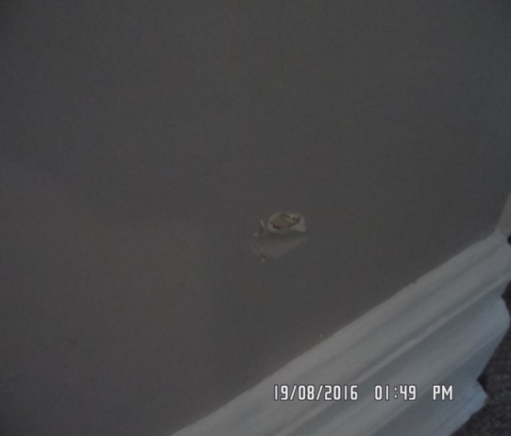

Open shelves (built-in) Sofa

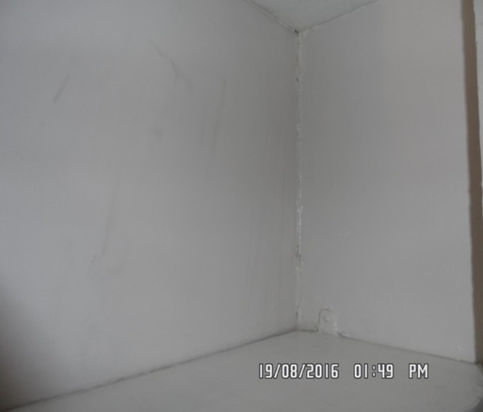 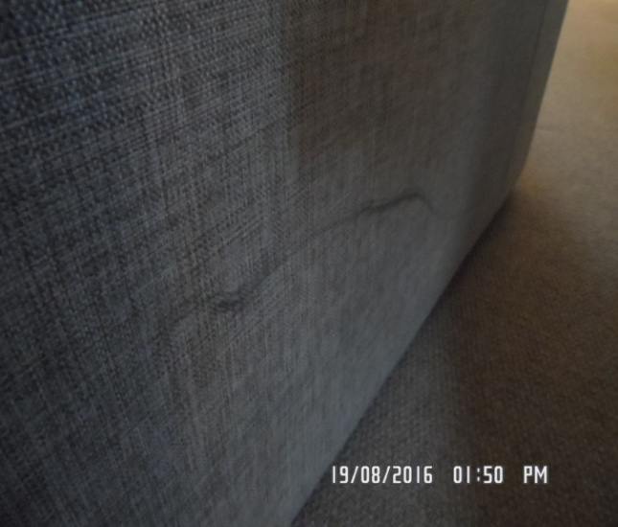

Dining table Side table

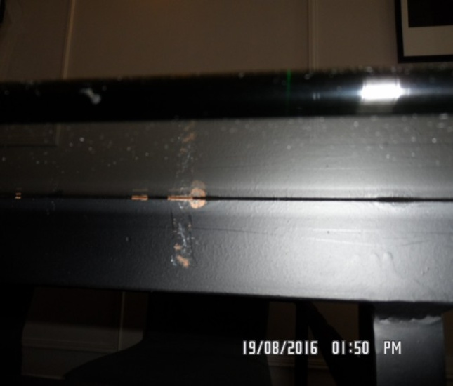 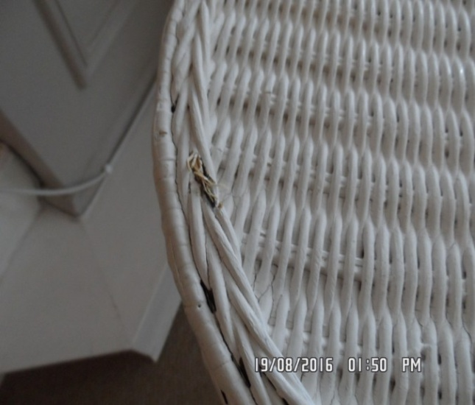

Window seat

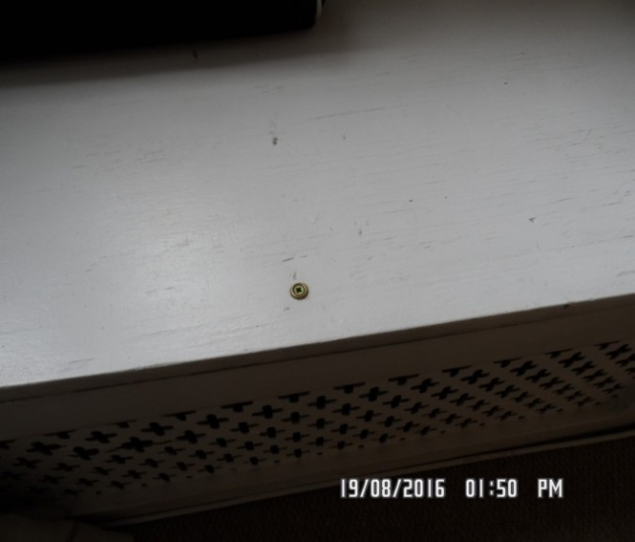

# KITCHEN

|  |  |  |  |
| --- | --- | --- | --- |
| **Door** | White painted door frame  Brushed steel threshold | 1. Painted over defects  2. Threshold is slightly marked  Few light marks to framework  1 x Chip above entrance with slight splash marks |  |
| **Ceiling** | Painted white  White painted hatch | 1. Good order  2. Hatch cracking to low level  3. Not closely inspected to interior  4. 1 or 2 x Scuffs around light above hob |  |
| **Lighting** | 6 x Chrome rimmed halogen lights | 1. Working |  |
| **Woodwork** | Painted white | Bit dusty |  |

# KITCHEN

|  |  |  |  |
| --- | --- | --- | --- |
| **Walls** | Part painted white  Part white ceramic tiling  Part glass splashback | 1. Painted over defects  2. Light general usage |  |
|  | Back wall  Entrance to room | 1. Tiling grout is slightly discoloured |  |
|  | Left hand side wall  2 x White plastic double sockets  1 x White plastic fuse point  Hatch frame painted white | 1. Paint marked to hatch to reception room  2. Painted over defects to frame  3. Chip right hand side |  |
|  | Front wall  1 x White plastic oven switch  3 x White plastic fuse points  1 x White plastic double socket | 1. Grouting good order |  |
|  | Right hand side wall |  |  |
| **Flooring** | Pale light greytiling | Good order  Looks new  Slight discolouration to grout |  |

# KITCHEN

|  |  |  |  |
| --- | --- | --- | --- |
| **Window** | No window |  |  |
| **Unit Description - Units are inspected from left to right** | White laminate high gloss flush doors  Brushed steel long handles  Interiors: white laminate |  |  |
| **Wall unit 1** | Single cupboard  3 x Shelves  1 x Base shelf |  |  |
| **Wall unit 2** | Single cupboard  2 x Shelves  1 x Base shelf |  |  |
| **Extractor** | Brushed steel chimney effect Whirlpool extractor | 1. Lights in working order  2. Extractor in working order |  |
| **Wall unit 3** | Single cupboard  2 x Shelves  1 x Base shelf | Looks new |  |

# KITCHEN

|  |  |  |  |
| --- | --- | --- | --- |
| **Wall unit 4** | Corner cupboard  3 x Shelves  1 x Base shelf | Few minor stains to base shelf |  |
| **Wall unit 5** | Single cupboard  3 x Shelves  1 x Base shelf | Clean, good order |  |
| **Wall unit 6** | Single cupboard  3 x Shelves  1 x Base shelf | Clean, good order |  |
| **Base unit 1** | 1 x Drawer  Single cupboard  1 x Shelf  1 x Base shelf | Chip to base shelf left hand side |  |
| **Base unit 2** | Corner cupboard  1 x Shelf  1 x Base shelf | Good order  Right hand door has slight splash marks with 6 x Pinholes  Interior base shelf has 1 x Drill hole |  |

# KITCHEN

|  |  |  |  |
| --- | --- | --- | --- |
| **Base unit 3** | 1 x Fascia below the oven | 1. Good order |  |
| **Base unit 4** | Single cupboard under sink  1 x Shelf  1 x Base shelf | Shelf base fallen  1 x screw in shelf  Very heavy cracking to back wall bricks  Most of the back wall is missing  Light stain to shelf – possibly will clean off |  |
| **Base unit 5** | 3-drawer unit  1 x with grey plastic cutlery tray | 1. Good order  Requires final wipe |  |
| **Worktop** | White gloss laminate in 3 pieces | Looks new  A couple of very minor usage marks  Please see picture of sealant |  |

# KITCHEN

|  |  |  |  |
| --- | --- | --- | --- |
| **Washing machine** | IndesitIWDE126  S.No: 50324495880624630295 | 1. Power tested  Slight discolouration to interior seal |  |
| **Hob** | Brushed steel Hotpoint 4-ring electric surround with glass base | New  Power tested |  |
| **Oven** | Steel Hotpoint  S.No: 50304020203806040100  2 x Controls  3 x Push buttons  Glass fronted door with steel handle  Interior: 2 x Chrome shelves  1 x Grey tray with chrome griddle tray | Good order / power tested |  |
| **Dishwasher** | Blomberg  Serial number – 15800364-04  2 x Crockery racks  1 x Grey plastic cutlery basket | Power tested  Clean to interior, as new |  |

# KITCHEN

|  |  |  |  |
| --- | --- | --- | --- |
| **Fridge/Freezer** | Indesit integrated fridge/ freezer  S.No: 50323502047778930203  3 x Door shelves  1 x Crisper  4 x glass shelves  Freezer  2 x Drawers  1 x Flap Super freeze compartment | Power tested / light working order  Clean, as new |  |
| **Sink** | Stainless steel 1 bowl drainer to left hand side  1 x Chrome waste  1 x Chrome strainer style plug  1 x Chrome mixer tap with pull out hose and spray function | 1. Basket is scorch marked  2. Sink is clean with cleaning abrasions  3. Slightly tarnished / requires further wipe  Scattered scratches to drainer and interior bowl  Slight lime scale to shower tap |  |
| **Crockery** | 1 x Dinner plate  13 x Set cutlery set  1 x Knife block with 4 x Knives |  |  |

# KITCHEN

|  |  |  |  |
| --- | --- | --- | --- |
| **Further crockery seen on dining table** | 4 x Dinner plates  4 x Side plates  4 x Knives  4 x Forks  4 x Soup spoons |  |  |
| **Toaster** | Toaster |  |  |
| **Kettle** | Kettle |  |  |

Kitchen Kitchen

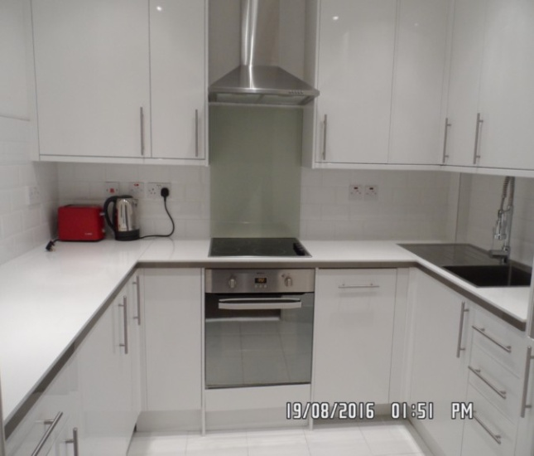 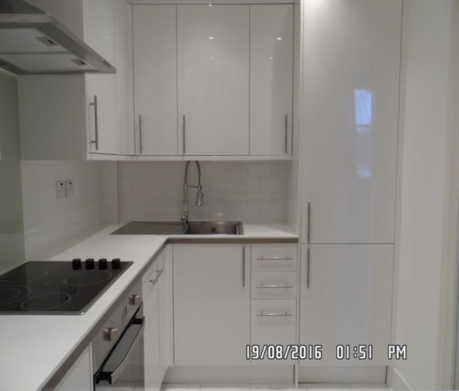

Flooring Worktop

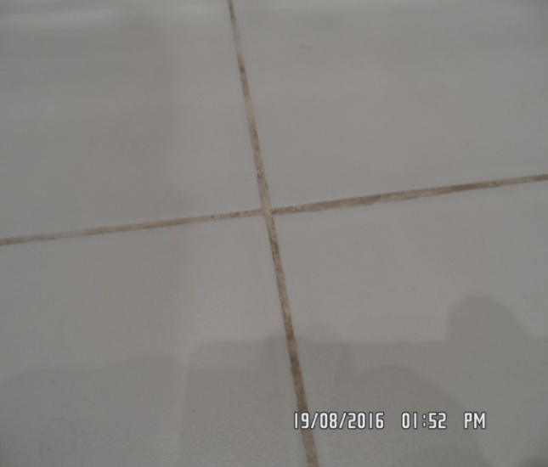 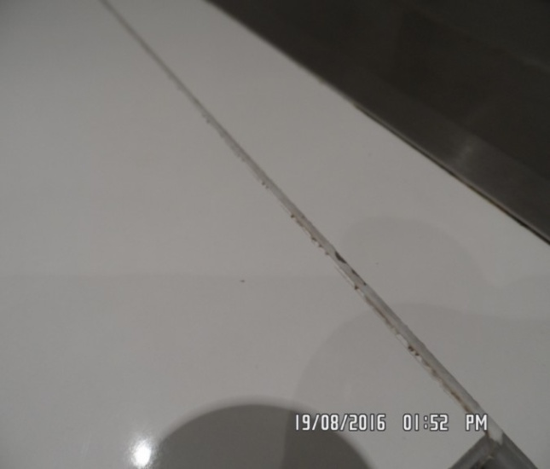

Hatch frame Access panel (Ceiling)

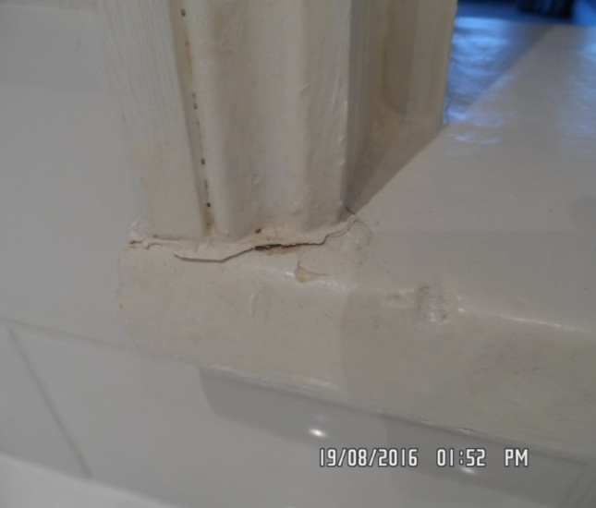 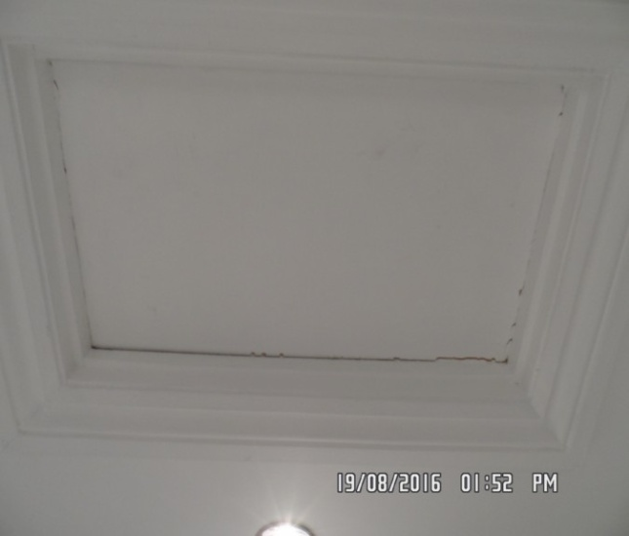

Light Base unit

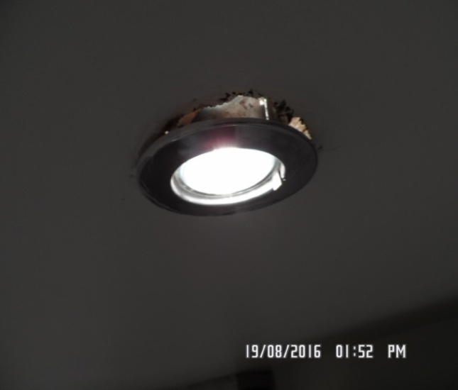 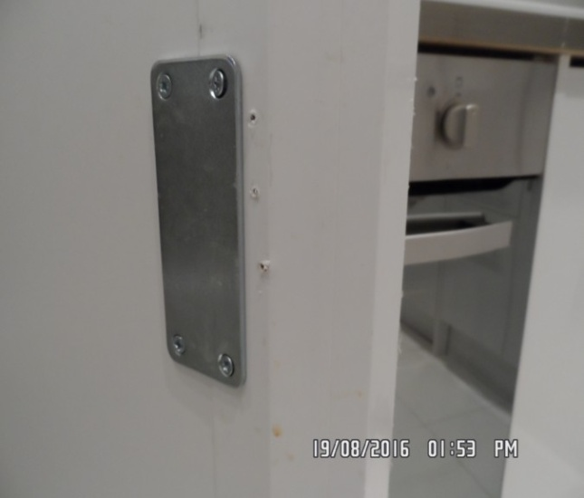

Base unit Washing machine

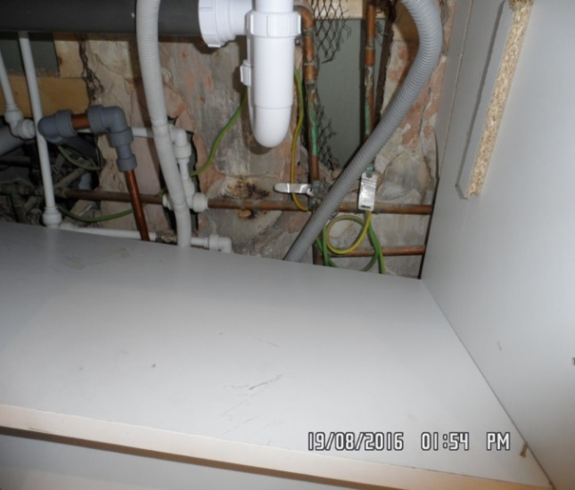 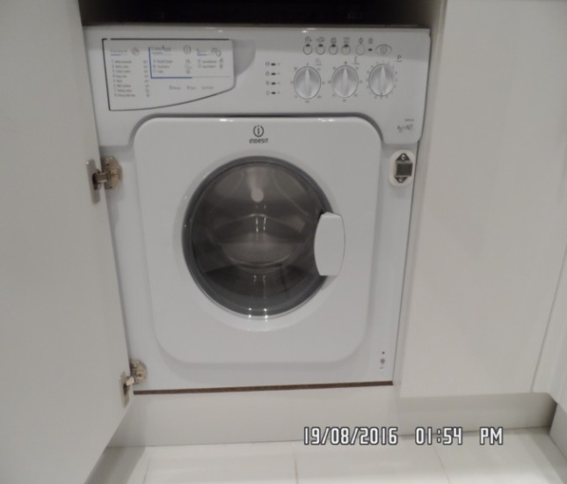

Soap tray Oven

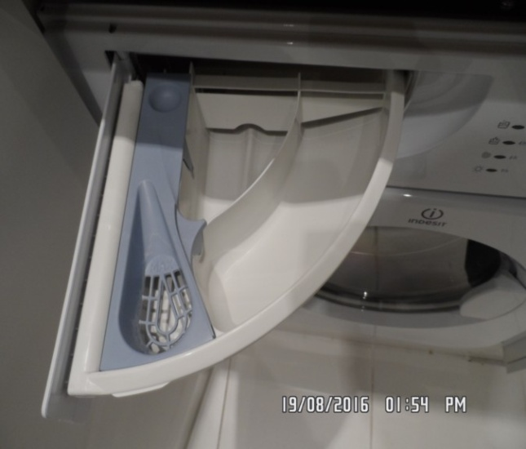 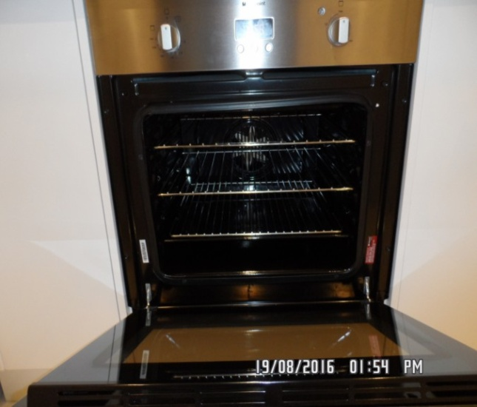

Hob Extractor

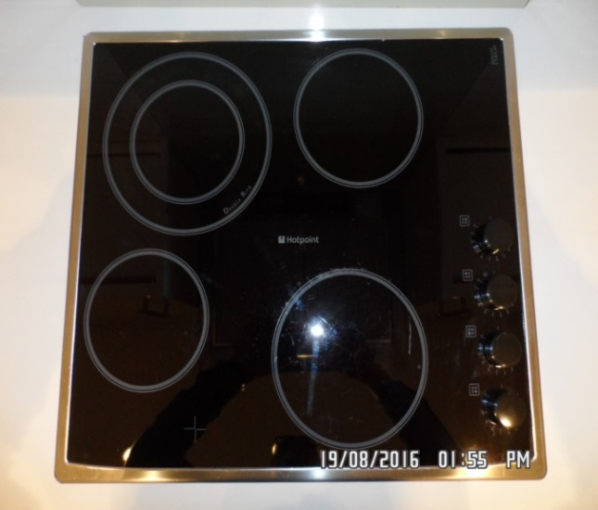 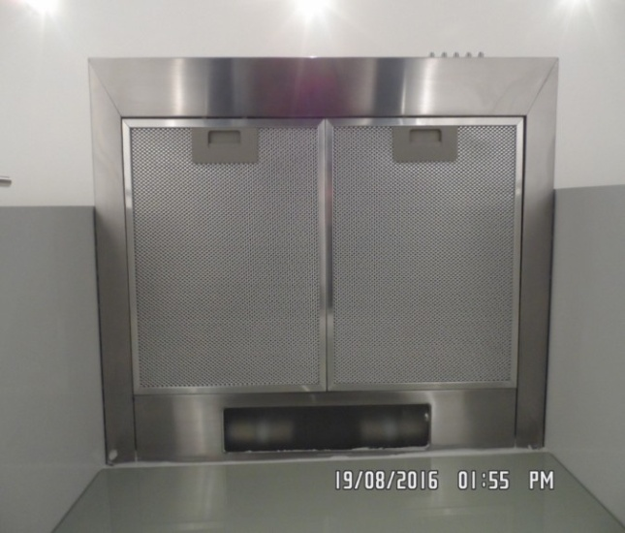

Dishwasher Fridge

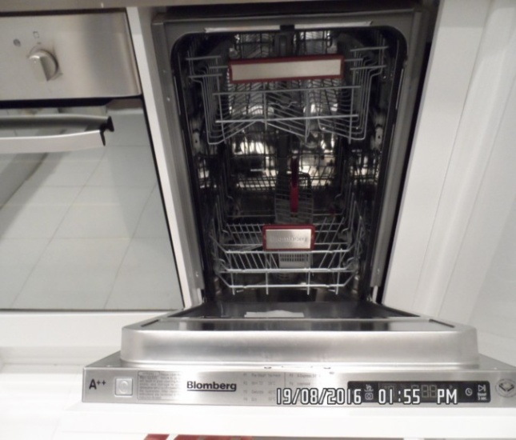 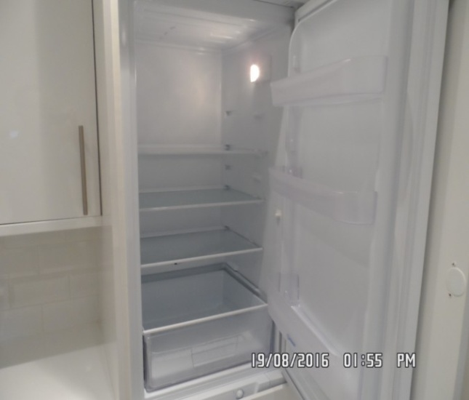

Freezer Sink

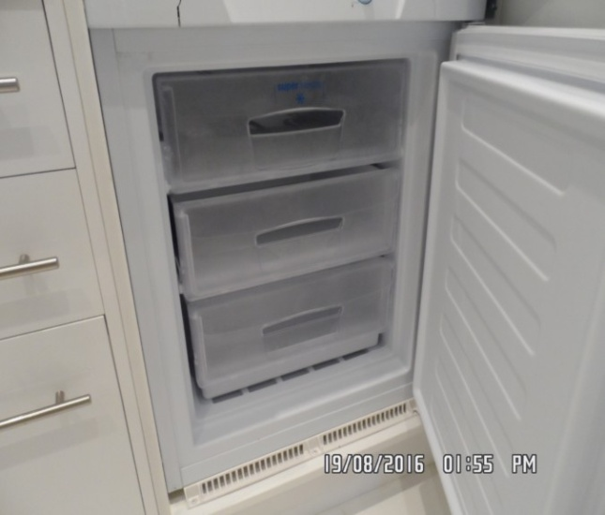 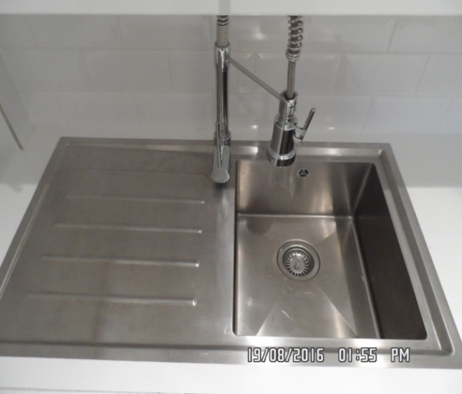

Sink tap

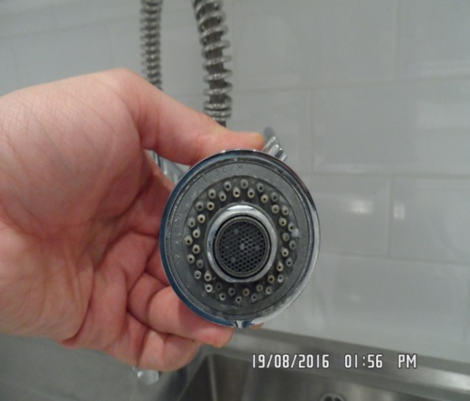

# BATHROOM

|  |  |  |  |
| --- | --- | --- | --- |
| **Door** | White painted door frame, white painted panelled door  White ceramic and gilt pull  Brushed steel threshold | 1. Painted over defects  2. Pull is slightly paint marked  3. Threshold in good order  Discolouring to lower panel exterior  Patched up paint  Door handle loose |  |
| **Interior** | White painted door frame, white painted panelled door  White ceramic and gilt door plate  White ceramic and gilt door knob  White ceramic and gilt lock cover  2 x Chrome double hooks | 1. Painted over defects  2. Knob is slightly paint marked and very loose |  |
| **Ceiling** | Painted white  1 x white extractor fan | A few orange spots above shower  Slight shading above extractor fan  Not tested |  |
| **Lighting** | 4 x white rimmed halogen lights | Good order |  |

# BATHROOM

|  |  |  |  |
| --- | --- | --- | --- |
| **Walls** | Part painted white  Part light grey tiling | Tiles are unevenly laid  Some not flush |  |
|  | Back wall  Entrance to room | 1 x chip to tile left hand side mirror |  |
|  | Left hand side wall  Thin white border tile to high level | Sealant in corner between sink and wall at low/ mid level is messy |  |
|  | Front wall | Light discolouration to grout in small area |  |
|  | Right hand side wall | Drips by W.C and to wall at low level |  |
| **Woodwork** | Painted white | Painted over defects  1 x Chip below radiator  Drip marks near toilet |  |

# BATHROOM

|  |  |  |  |
| --- | --- | --- | --- |
| **Flooring** | Pale greytiling | Very minor chip to 1-tile forward entry  Grout slightly discoloured |  |
| **Window** | No window |  |  |
| **Sink** | Rectangular ceramic sink  Chrome waste, pop up and mixer tap and overflow  Chrome mixer tap  Chrome pop-up and waste  Chrome overflow  Sink is sitting on white vanity  2 x doors  1 x Shelf  1 x Base shelf  2 x Chrome pulls | Plug and surround scratched  Tested and working  Green stuff around tap  New |  |
|  | White plastic worktop |  |  |

# BATHROOM

|  |  |  |  |
| --- | --- | --- | --- |
| **Vanity cupboard** | White painted frame, 2 white flush doors with brushed steel pulls  Interior: Painted white | 1. Part back wall fitted with pipes visible  3. Base shelf has painted over defects  Interior and exterior have slight drip marks |  |
| **Bath** | White enamel bath with chrome waste, chrome pop up, mixer tap  Chrome riser rail, hose  Wall mounted water fall square showerhead in chrome  Riser rail  Wall mounted mixer on chrome plug  Panel is new plastic moulded  White framed glass shower screen | Seal discoloured  Hinges are very loose – dangerous  Bath is chipped to tap end on ledge on side  Bath not tested  Waste tarnished  Shower head possible changed |  |

# BATHROOM

|  |  |  |  |
| --- | --- | --- | --- |
| **WC** | White cistern WC  White seat and lid  Chrome push flush | Tested and working |  |
| **Towel ring** | 1 x Wall mounted chrome |  |  |
| **Mirror** | 1 x Wall mounted | Good order  Right hand side low level bracket not seen |  |
| **Mirror** | 1 x Wall mounted large unframed | Slightly painted at top edges |  |
| **Ledge** | White wood laminate | Some light surface scratching  Few stains from cleaning products requires final wipe |  |
| **Toilet roll holder** | 1 x Wall mounted chrome |  |  |
| **Towel rail** | 1 x Wall mounted chrome | Some tarnishing to rails |  |
| **Heated towel rail** | 1 x Wall mounted chrome | 1. Cap not seen to left hand side |  |

Bathroom Bathroom

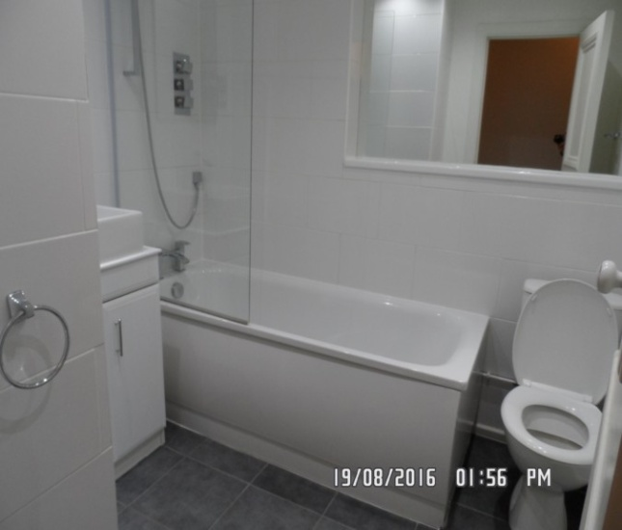 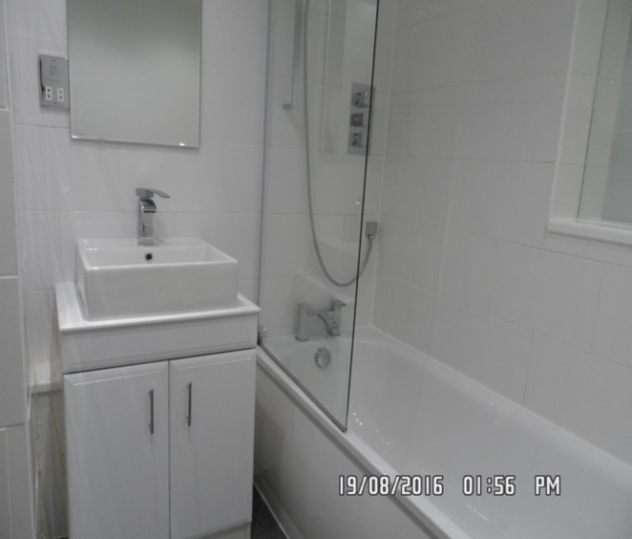

Skirting/ valve cap Sealant (between basin wall)

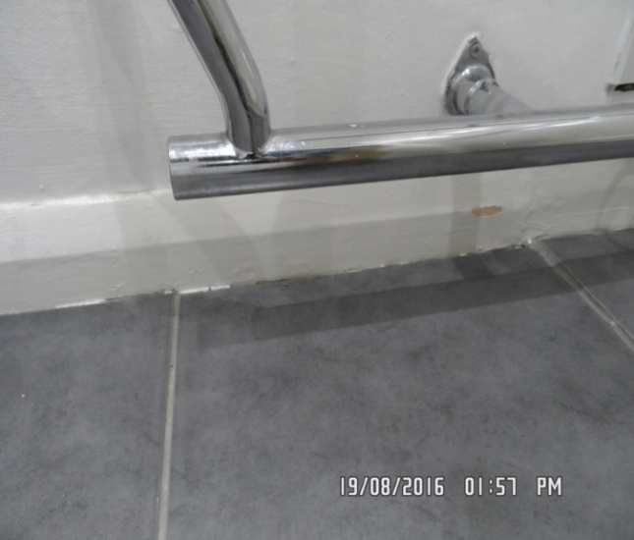 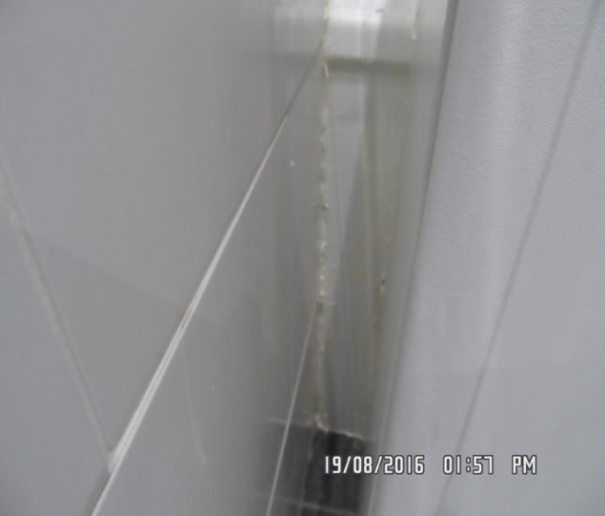

Flooring Tiles

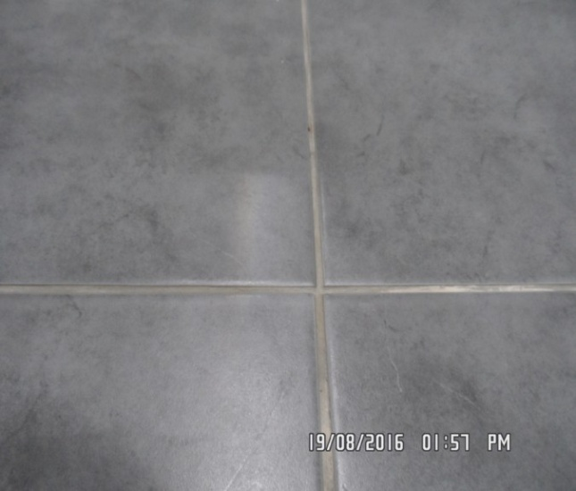 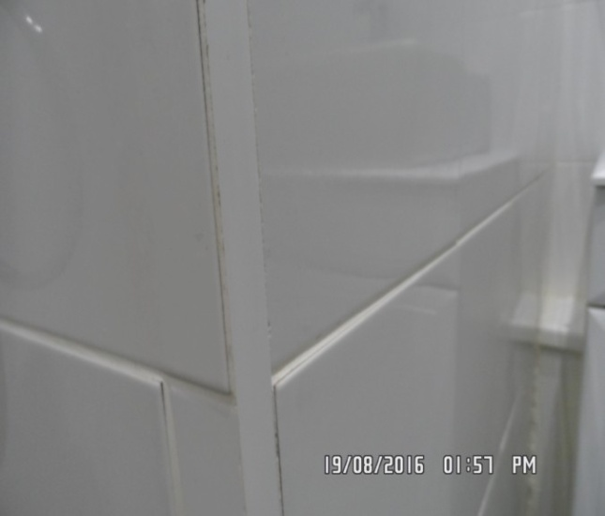

Toilet/ walls Basin

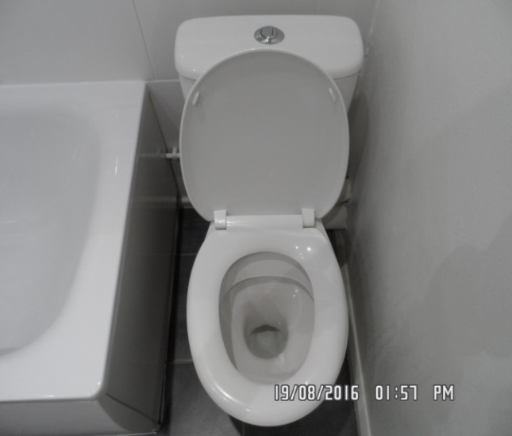 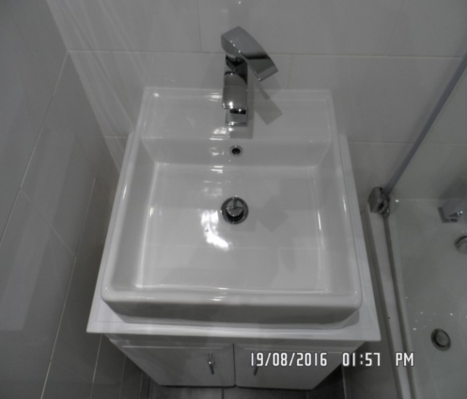

Tap Waste

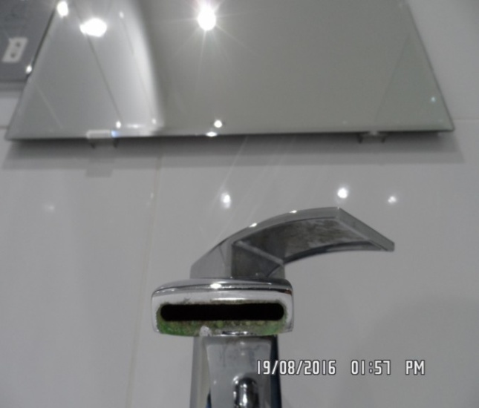 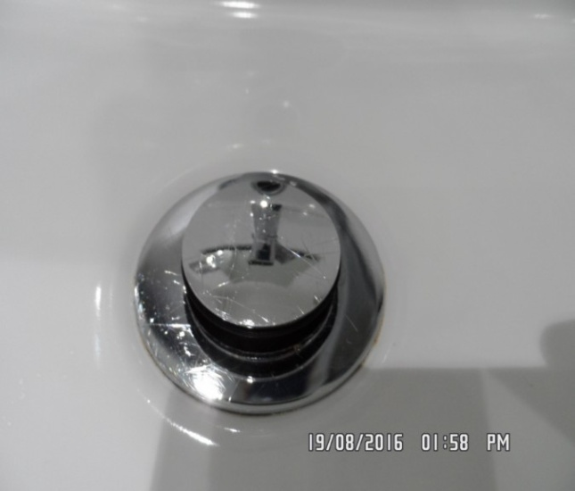

Bathtub Showerhead

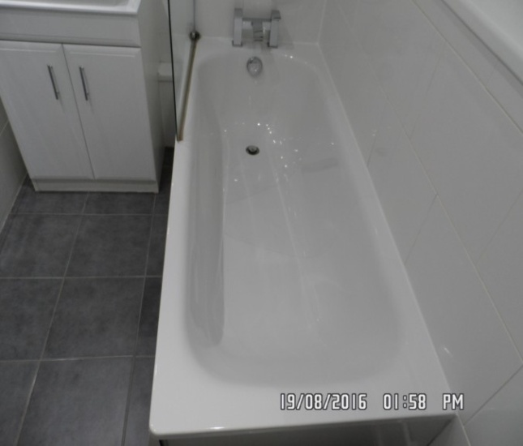 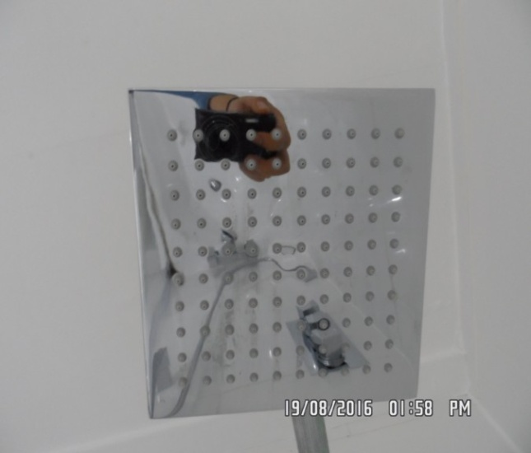

Bathroom showerhead Waste

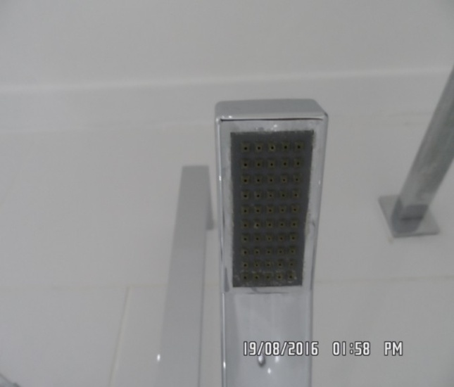 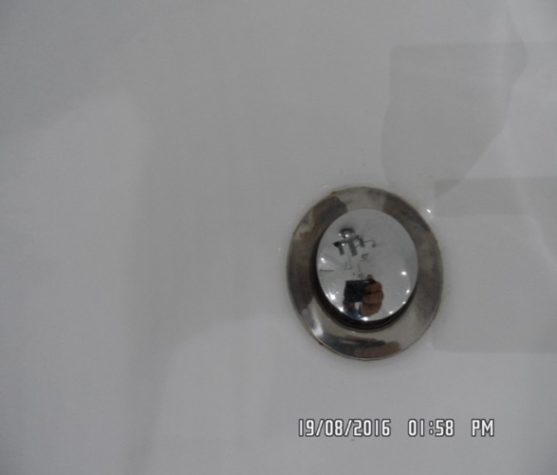

Shelf above toilet/ bath

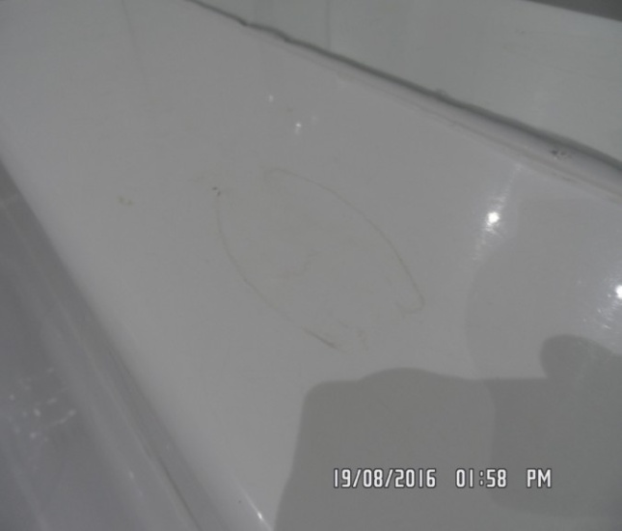

**BEDROOM**

|  |  |  |  |
| --- | --- | --- | --- |
| **Door** | White painted door frame, white painted panelled door  White ceramic and gilt finger plate  White ceramic and gilt door pull  White ceramic and gilt lock cover  Brushed steel threshold | 1. Freshly painted to door and frame with painted over defects  2. Threshold is slightly marked and in use  3. Finger plate is worn and cracked  4. Pull is slightly loose  5. 1 or 2 minor chips to base  Rub mark below push plate  1 or 2 x scattered light usage marks  1 x Chip to bottom of top panel  Paint is patchy in places |  |
| **Interior** | White painted door frame, white painted panelled door  White ceramic and gilt door knob  White ceramic and gilt lock cover | 1. Freshly painted to door with painted over defects  2. Cable clipped to top right and left of frame  3. Piece broken off to lock cover  4. Couple of minor scuffs seen to low level  Patchy over paintwork low level  Cracking/ flaking around top panel |  |

**BEDROOM**

|  |  |  |  |
| --- | --- | --- | --- |
| **Ceiling** | White painted | 1. Good order  2. Some patchy paint work around piping to front wall  1 or 2 x scattered rub marks  Painted over defects |  |
| **Lighting** | Now overpainted glass cover to light | Working order |  |
| **Walls** | Painted stone | 1. Painted over defects  Few scattered light mid to low level marks  Faint scuff line to right hand side high level |  |
|  | Back wall  1 x White plastic double light switch  Entrance to room | Further scuffs below windows and above bed |  |
|  | Left hand side wall  2 x White plastic double sockets  1 x White plastic light switch  2 x Wall mounted chrome and Perspex lights | 1. Lights in working order  2. Left hand side light is missing the Perspex cover |  |

**BEDROOM**

|  |  |  |  |
| --- | --- | --- | --- |
|  | Front wall | 1. Paint work is slightly patchy around pipe work  2. Painted over defects |  |
|  | Right hand side wall  1 x White plastic double socket | Good order  Not inspected behind furniture |  |
| **Woodwork** | Painted white  1 x White plastic telephone socket | 1. Freshly painted  2. Cable clipped to left and right hand side  1 or 2 x scattered minor scuffs  Painted over defects |  |
| **Flooring** | Beige fitted carpet  White painted trim fitted to edge | 1. Slightly worn |  |
| **Window 1 – left hand side** | White painted frame, white painted casement windows 4 x panes  White painted arms and 2 brass levers  1 x Brass lock  2 x Fixed panels  Sill painted white | 1. Glazing is slightly smeary to interior and is soiled to exterior  2. Painted over defects to sill  Heavy paint flaking to lower left hand window right hand side  Scuffing to sill |  |

**BEDROOM**

|  |  |  |  |
| --- | --- | --- | --- |
| **Window 2 – right hand side** | White painted frame, white painted casement window  White painted arms and 2 brass levers  1 x Brass lock  2 x Fixed panels  Sill painted white ledge | 1. Cleaning abrasions seen to glazing  2. Glazing is soiled to exterior  3. Sill is painted with painted over defects  Scuffing to sill |  |
| **Curtains** | 1 x Black metal curtain rail  Stone coloured curtains  2 x Metal wall mounted cleats  Pair of light beige floor length lined curtains | 1. No finials  2. Slightly paint marked |  |
| **Blind** | 1 x Cream roller blind with cord pulley | 1. Blind is very aged and discoloured and spot marked  2. Cord is very grubby |  |
| **Bed** | Blue and white striped king size divan bed with base and mattress | 1. 2 x chips to upper corners of headboard  Unable to inspect fully dressed |  |
| **Bedside table** | 2 x Taupe wood with 1 drawer with chrome pulls  1 x Shelf | Light general usage |  |

**BEDROOM**

|  |  |  |  |
| --- | --- | --- | --- |
| **Wardrobe Description** | White painted frame  2 x Mirrored fronted doors  Right hand side is a fixed panel  1 x Chrome pull  6 x Screws seen to each door  Painted white to skirting  Flooring is wood laminate | 1. Cable clipped to left hand side and top and right hand side  2. 4 x Screw covers not seen  3. Defects to top left hand side by screw cover  4. Chip seen to mid level left hand side door  5. Chip around mid level right hand side door  6. Further defects around the hinges  7. General scratches and light marks seen to mirrored panels  8. Water marked to skirting and stained to right hand side  9. Flooring has cut out for pipe work and appears in good order  10. 1 x Drill hole to right hand side low level  Right hand side mirror missing something handle? – note seen |  |

**BEDROOM**

|  |  |  |  |
| --- | --- | --- | --- |
| **Wardrobe interior** | White painted panelled door  Walls painted white  2 x White plastic hooks  1 x White plastic ceiling rose and bulb  White painted over hatch to the ceiling | 1. painted over defects  2. Painted over defects to wall  3. Old defects under  4. Light in working order  5. Hatch is flush painted  6. Some scuffing to interior walls  Scattered cracking to woodwork and walls right hand side  Spots of water damage to ceiling |  |
| **Wardrobe contents** | 5 x White painted shelves  1 x Chrome hanging rail  Folded linen added to interior | 1. Painted over defects to shelves  2. Too high to inspect high shelves  Not closely inspected |  |

**BEDROOM**

|  |  |  |  |
| --- | --- | --- | --- |
| **Chest of drawers** | 2 x Medium wood  3 drawers | 1. Usage marks to tops  2. 1 or 2 scratches seen  Scattered light edge chips  1 or 2 x surface scratches to drawer fascias |  |
| **Free standing wardrobe** | Mid wood frame with brushed steel and glass panelled door  Interior: Wood laminate  2 x Grey metal hanging rails  1 x Pull out wooden divider drawer  1 x Base shelf | 1. Good order |  |
| **Radiator** | 1 x White painted cover with white painted lattice front | 1. Unable to inspect fully as set in corner behind wardrobe  2. Cover is loose |  |
| **Miscellaneous** | Pewter vase  2 x Taupe coloured metal lamps | Working |  |

**BEDROOM**

|  |  |  |  |
| --- | --- | --- | --- |
| **Linen** | 1 x Leather picture frame  2 x Pillows and 2 x Cases  1 x Flat sheet  1 x Fitted sheet  1 x Brown/ grey velour blanket  1 x Cream valance  1 x Mattress protector  3 x Zigzag black/ beige cushions | In Reception  On bed  On bed  On bed |  |
| **Print** | Picture / print to wall |  |  |

Bedroom Bedroom

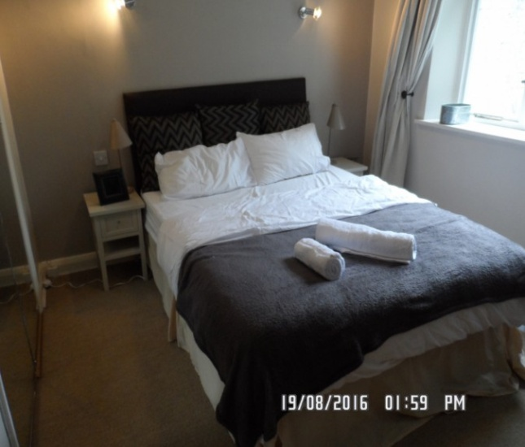 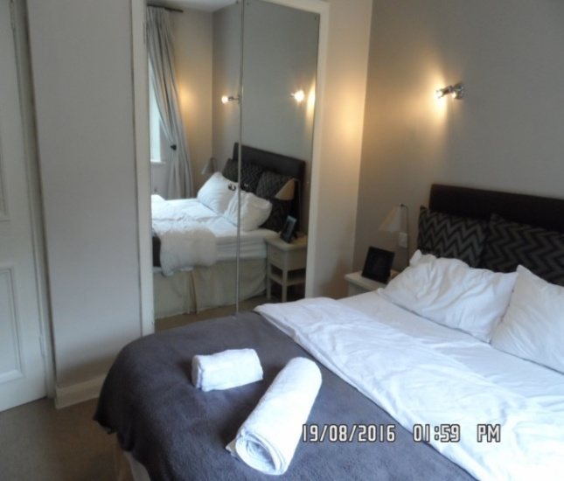

Walls Headboard

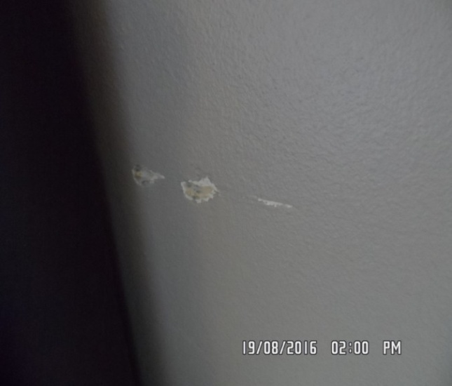 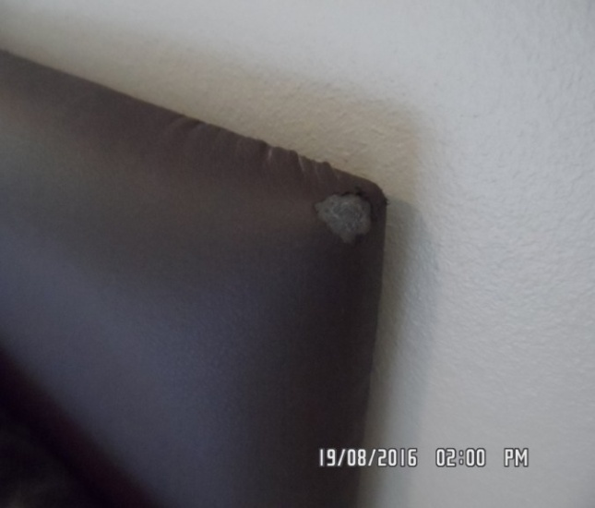

Window frame/ handle Window sill

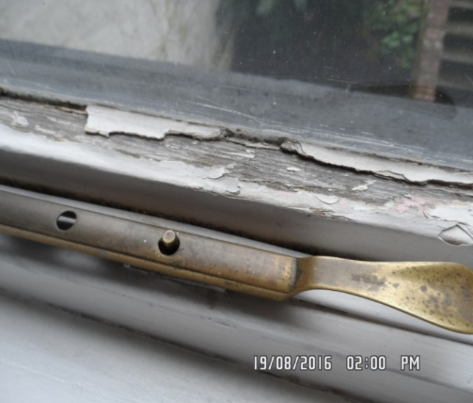 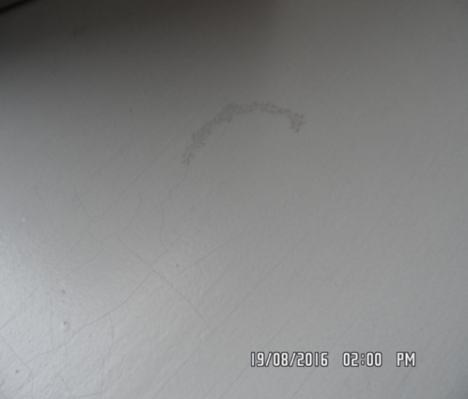

Ceiling Bedroom

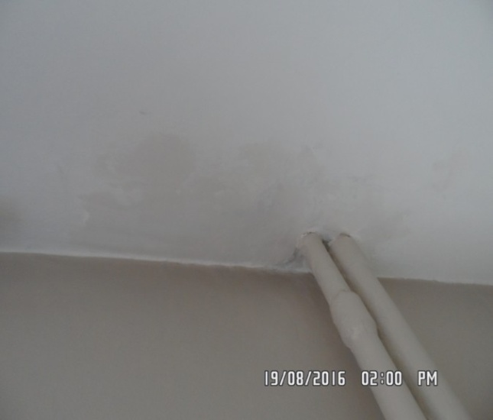 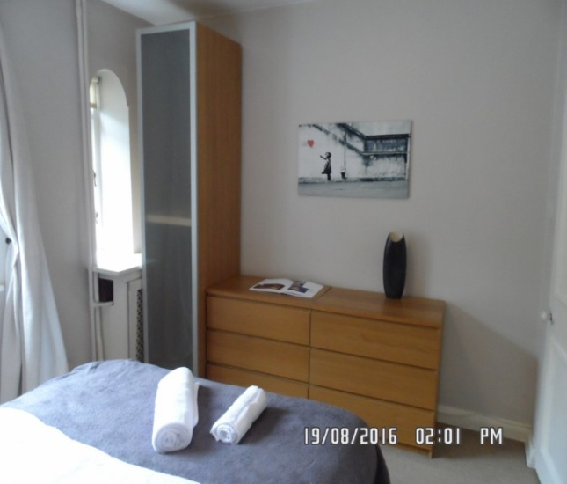

Wardrobe mirror Wardrobe mirror

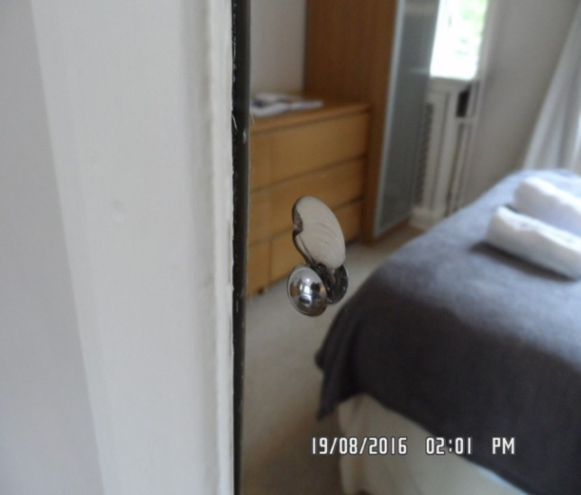 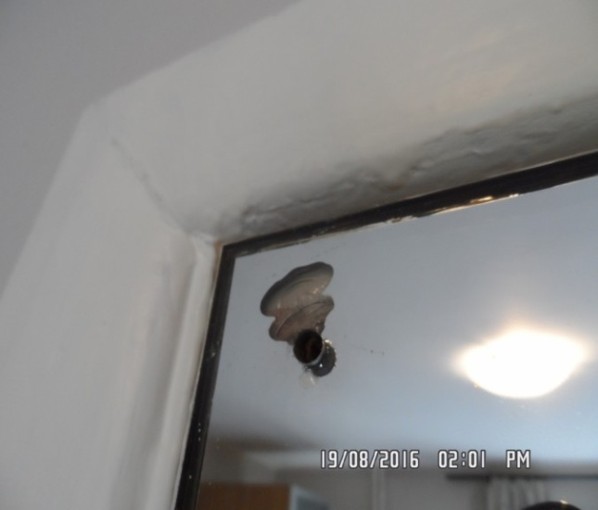

Wardrobe Interior walls

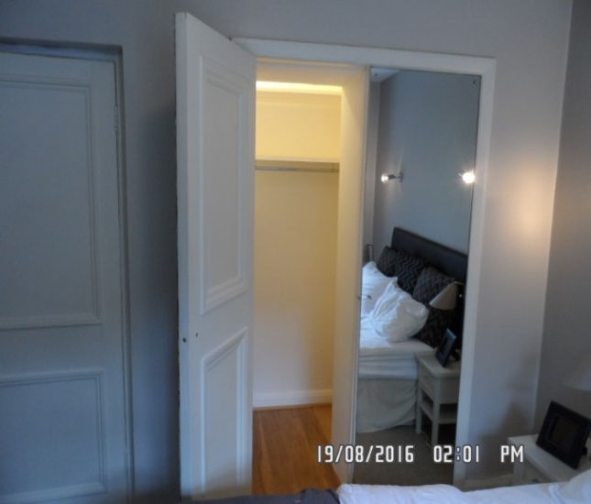 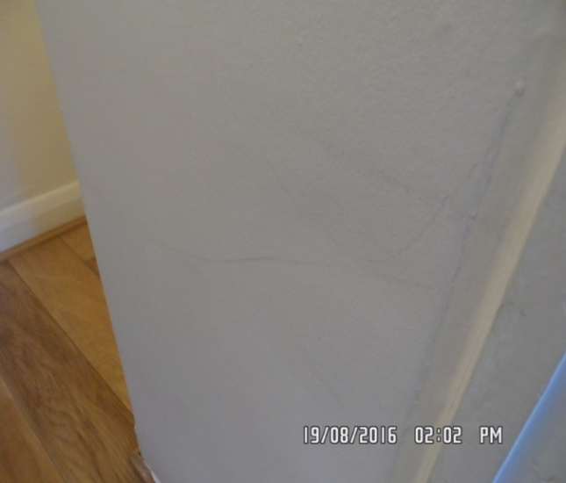

Interior walls Ceiling/ shelf

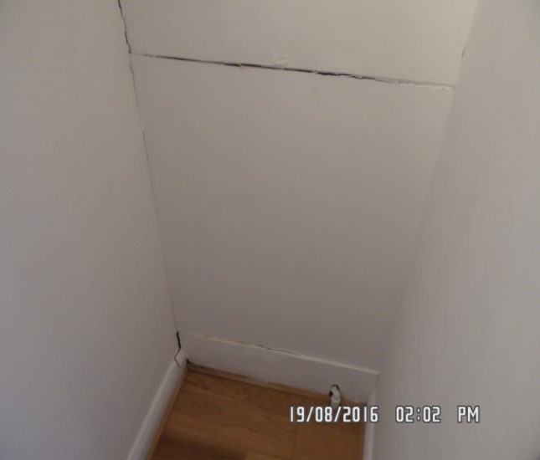 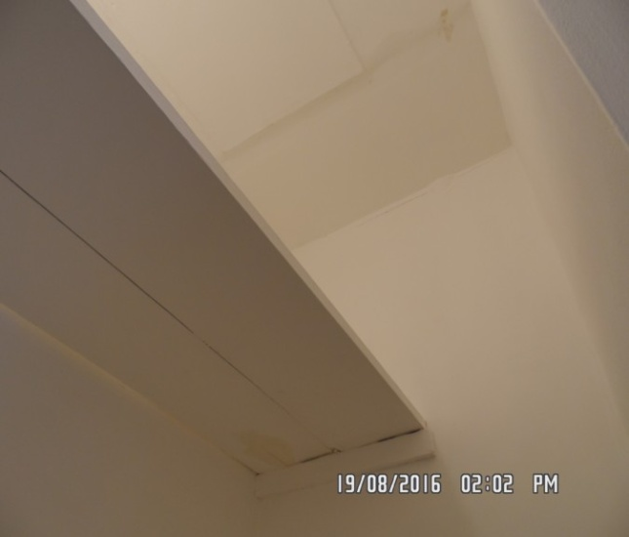

# DECLARATION AT CHECK IN

This inventory has been examined and, subject to marginal comments found to be correct.

## On behalf of the landlord

on behalf of the tenant \_\_\_\_\_

commencement of tenancy **\_\_\_\_\_\_**

## **N.B**

This inventory is correct to the best of our knowledge but advise you to examine its contents prior to signing, as we can not be held responsible for any errors or omissions. Descriptions are for identification purposes only.

The relevant utility companies must check all meter readings, as we can not be held responsible for any discrepancies

**Please ensure that all items listed in this inventory are in the same location at the end of the tenancy.**

**ADDITIONAL AMENDMENTS**

|  |  |  |
| --- | --- | --- |
| DATE | DESCRIPTION OF CHANGES | AGENTS/LANDLORD SIGNATURE |
|  |  |  |
|  |  |  |
|  |  |  |
|  |  |  |
|  |  |  |
|  |  |  |
|  |  |  |
|  |  |  |
|  |  |  |

WHEN ADDITIONS/AMENDMENTS ARE MADE BY THE LANDLORD, TENANT OR AGENT THE RELATIVE PARTIES MUST BE INFORMED

**GENERAL COMMENT**

It should be noted that it is not the responsibility of the Inventory Clerk to open, unpack, empty or itemise items stored in carrier bags

or other containers  unless it is made specifically clear they are the property of the Landlord.

